FINAL PROJECT REPORT

Streamlining IT Procurement: Automating Standard Laptop Orders with Flow Designer
ServiceNow Project
Detail | Information
Project Title | Streamlining IT Procurement: Automating Standard Laptop Orders with Flow Designer
Team ID | SWTID-2026-6867
Date | 03 October 2026
Platform | ServiceNow (Service Catalog and Flow Designer)

Team Members
S.No | Name | Role
1 | Shanmuga Kathiresh V | Team Lead
2 | Siva Sastha R K | Member
3 | Shriman C | Member
4 | Shrikrishna Sripathy | Member
5 | Sarva Mukesh M | Member

1. INTRODUCTION

1.1 Project Overview
The project “Streamlining IT Procurement: Automating Standard Laptop Orders with Flow Designer” uses ServiceNow Flow Designer to automate the standard laptop procurement process. In many organizations, a standard laptop request is handled through emails, spreadsheets and manual follow-ups. This project replaces that manual handling with a structured, repeatable workflow built on the ServiceNow platform.
ServiceNow Service Catalog provides the entry point for the process. A user opens the Service Catalog, selects the Standard Laptop catalog item, enters the required information and submits the request. Submission triggers a flow built in Flow Designer, which generates an approval, waits for the approval decision, creates a procurement task once the request is approved, and keeps the request status updated as procurement progresses.
The end-to-end workflow therefore covers laptop request submission, approval, procurement task creation, status updates and fulfillment. The requester can follow the progress of the request from a single place, and the procurement team receives a task automatically instead of having to create it by hand.

1.2 Purpose
The purpose of the project is to provide a structured and repeatable procurement workflow for standard laptops. The specific objectives are to:
- Reduce manual laptop procurement steps
- Automate standard laptop requests
- Improve approval processing
- Automatically create procurement tasks
- Maintain consistent request status updates
- Reduce processing delays
- Improve visibility of procurement requests
- Provide a structured and repeatable procurement workflow

2. IDEATION PHASE

2.1 Problem Statement
Standard laptop procurement requests are frequently processed manually. A request is received, forwarded to an approver, followed up, and then re-entered or handed over to the procurement team so that a task can be raised. Each of these hand-offs depends on people remembering to act, which makes the process slow and inconsistent. The main problems are:
- Manual request processing: requests are reviewed and routed by hand.
- Delays in approvals: approvers are not prompted in a consistent way, so requests wait.
- Manual creation of procurement tasks: tasks are raised by staff after approval, with the risk of omission or duplication.
- Inconsistent status updates: requesters are not told reliably where their request stands.
- Lack of centralized tracking: request information is spread across mails and files.
- Repetitive administrative work: the same steps are repeated for every standard laptop order.
- Difficulty monitoring procurement progress: there is no single view of requests and their stages.
A standard laptop order follows the same pattern every time, which makes it a strong candidate for automation.

2.2 Empathy Map Canvas
The Empathy Map Canvas below captures the perspective of the stakeholders involved in laptop procurement, namely the employee who requests the laptop and the IT procurement team that fulfills the request.
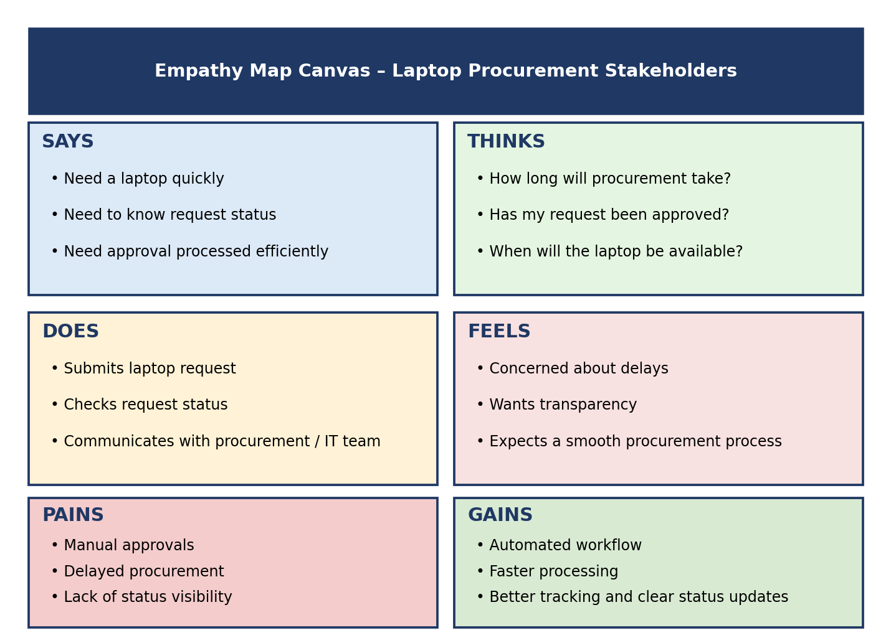
Figure 2.1: Empathy Map Canvas for laptop procurement stakeholders
Quadrant | Summary
SAYS | Need a laptop quickly; need to know request status; need approval to be processed efficiently.
THINKS | How long will procurement take? Has my request been approved? When will the laptop be available?
DOES | Submits laptop request; checks request status; communicates with the procurement / IT team.
FEELS | Concerned about delays; wants transparency; expects a smooth procurement process.
PAINS | Manual approvals; delayed procurement; lack of status visibility.
GAINS | Automated workflow; faster processing; better tracking; clear status updates.

2.3 Brainstorming
The team held a brainstorming session to identify how the pain points from the Problem Statement and Empathy Map could be addressed. Each member proposed ideas, which were then grouped and discussed against their effect on the requester and the procurement team. The ideas considered were:
- Automating laptop requests through a Service Catalog item with a standard form
- Automating approvals so that an approval is generated as soon as a request is submitted
- Automatically creating procurement tasks once a request is approved
- Automated notifications to keep users informed
- Centralized request tracking on the ServiceNow platform
- Dashboard-based monitoring of procurement requests
- ServiceNow Flow Designer automation to tie these steps into one workflow
Flow Designer was selected for the proposed workflow because it is the native ServiceNow tool for automating business processes. It allows the trigger, approval, task creation and status update steps to be defined visually in one flow, without standalone code, and it works directly with ServiceNow records and the Service Catalog. The resulting flow is easy to read, test and modify when the procurement process changes.

3. REQUIREMENT ANALYSIS

3.1 Customer Journey map
The customer journey follows the requester from identifying the need for a laptop through to receiving it. The journey is divided into four phases: Request, Approval, Procurement and Fulfillment.
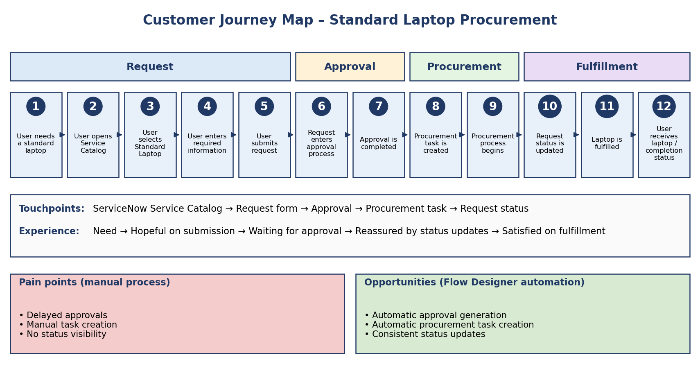
Figure 3.1: Customer Journey Map for standard laptop procurement
Step | Journey stage
1 | User needs a standard laptop
2 | User opens Service Catalog
3 | User selects Standard Laptop
4 | User enters required information
5 | User submits request
6 | Request enters approval process
7 | Approval is completed
8 | Procurement task is created
9 | Procurement process begins
10 | Request status is updated
11 | Laptop is fulfilled
12 | User receives the laptop / completion status

3.2 Solution Requirement
Functional Requirements
- Standard Laptop catalog item in the Service Catalog
- Laptop request form
- Required field validation
- Request submission
- Approval workflow
- Procurement task creation
- Status updates
- Request tracking
- Notifications where applicable
- Procurement dashboard / reporting
Non-Functional Requirements
Requirement | Description
Reliability | The flow must run consistently for every submitted standard laptop request.
Security | Access to requests, approvals and tasks is controlled through ServiceNow.
Usability | The catalog item and request form must be simple for employees to complete.
Maintainability | Flow logic should be easy to review and modify when procurement policy changes.
Scalability | The workflow should handle an increasing number of requests without redesign.
Performance | The flow should execute promptly after request submission.
Role-based access | Requesters, approvers and procurement staff see only what their roles permit.

3.3 Data Flow Diagram
The Data Flow Diagram shows how information moves through the ServiceNow platform, from the requester to the Service Catalog and the Standard Laptop request, then through Flow Designer, approval, procurement task, status update and fulfillment, and back to the user.
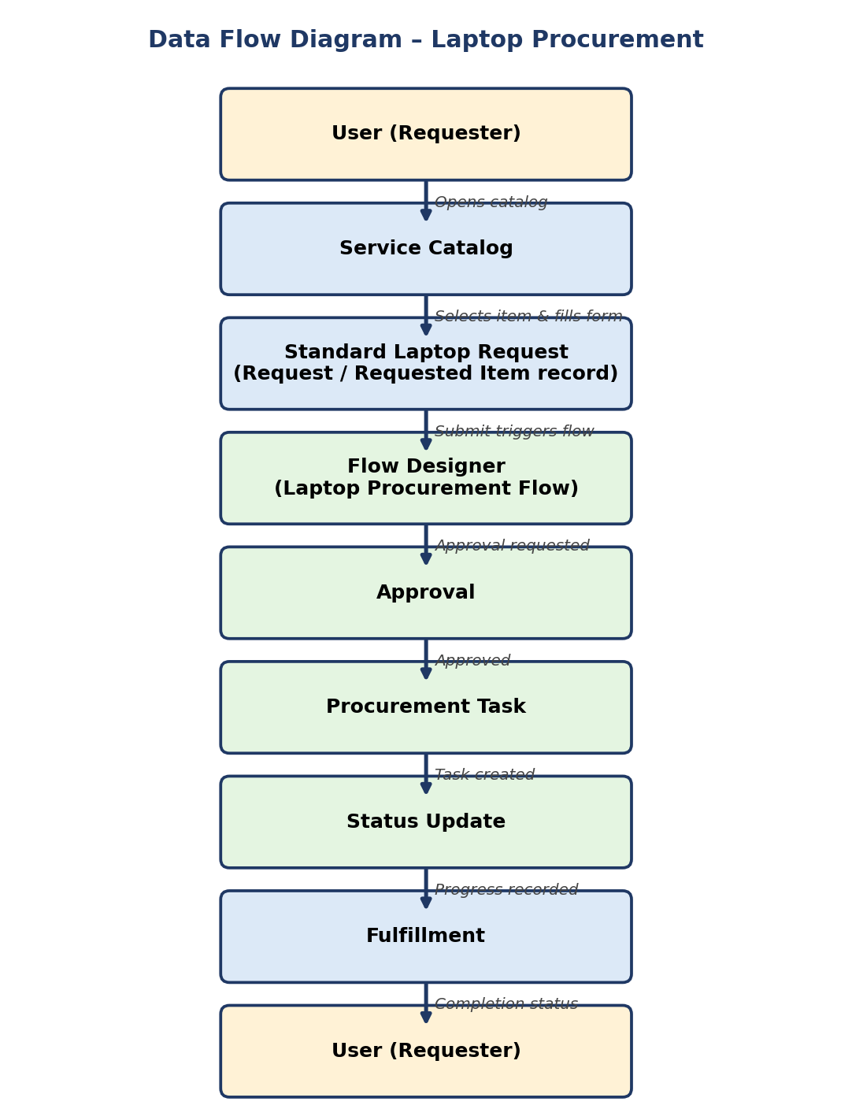
Figure 3.2: ServiceNow Data Flow Diagram for laptop procurement

3.4 Technology Stack
Component | Technology
Platform | ServiceNow
Automation | ServiceNow Flow Designer
Service Request | Service Catalog
Workflow | Flow Designer
Data | ServiceNow platform tables and records
Security | ServiceNow roles and permissions
Interface | ServiceNow user interface / Service Catalog
Testing | Functional Testing and Performance Testing

4. PROJECT DESIGN

4.1 Problem Solution Fit
The proposed ServiceNow Flow Designer solution maps directly to the problems identified during ideation. Each problem is addressed by a specific part of the automated flow, with an expected benefit.
Problem | Proposed Solution | Expected Benefit
Manual request processing | Flow automation triggered on request submission | Reduced manual effort
Approval delays | Automated approval workflow | Faster processing
Manual task creation | Automatic procurement task creation | Consistent task generation
Inconsistent status updates | Automated status updates in the flow | Reliable, current request status
Poor tracking | Status automation and dashboard | Better visibility
Repetitive administrative work | Repeatable standard flow | More time for the procurement team

4.2 Proposed Solution
The proposed solution is an automated laptop procurement workflow built with Service Catalog and Flow Designer. It works as follows:
- User opens Service Catalog.
- User selects Standard Laptop.
- User enters request details.
- User submits the request.
- Flow Designer triggers automatically.
- Approval is generated.
- Approval is processed.
- Procurement task is created.
- Request status is updated.
- Procurement continues.
- Completion / fulfillment status is recorded.
Once the request is submitted, the process requires no manual routing. Each stage updates the request so that the requester and the procurement team see the same status.

4.3 Solution Architecture
The architecture is entirely within the ServiceNow platform. The Service Catalog is the user-facing layer, Flow Designer is the automation layer, and approvals, procurement tasks and status management are records handled by the flow, using ServiceNow platform tables and role-based security.
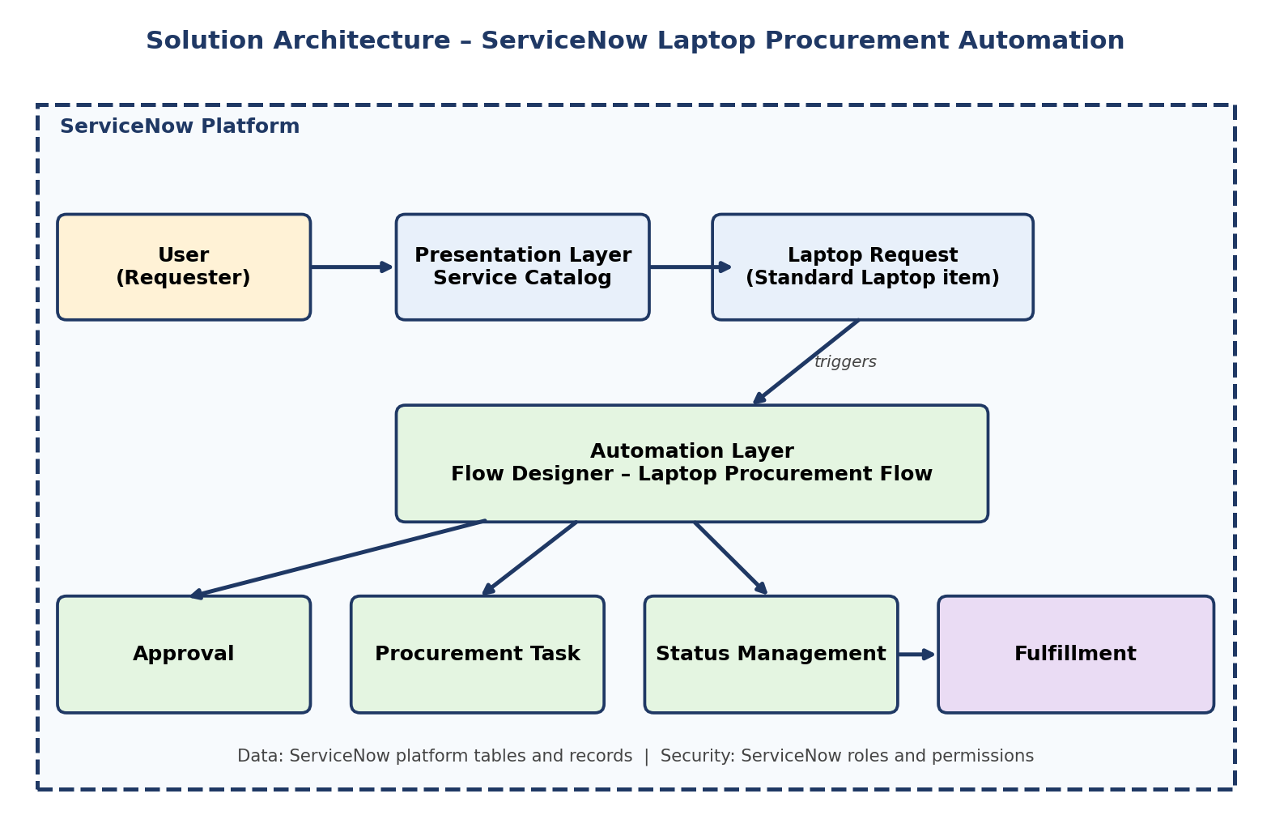
Figure 4.1: ServiceNow solution architecture for laptop procurement automation

5. PROJECT PLANNING & SCHEDULING

5.1 Project Planning
The project was organized into the following stages, each with its activities and deliverables.
No. | Stage | Activities | Deliverables
1 | Requirement Analysis | Gather the needs of requesters and the procurement team; define scope | Requirement list
2 | Problem Identification | Identify issues in manual laptop procurement | Problem statement
3 | ServiceNow Configuration | Prepare the ServiceNow instance, roles and access | Configured environment
4 | Catalog Item Creation | Create the Standard Laptop catalog item and request form with required fields | Standard Laptop catalog item
5 | Flow Designer Development | Build the Laptop Procurement Flow with the submission trigger | Laptop Procurement Flow
6 | Approval Configuration | Configure approval generation and handling in the flow | Approval step
7 | Procurement Task Configuration | Create the procurement task automatically after approval | Procurement task step
8 | Dashboard / Report Design | Design the procurement dashboard and report | Laptop Procurement Dashboard and report
9 | Functional Testing | Test catalog item, form, flow, approval, task and status | Functional test results
10 | Performance Testing | Test flow response and multiple request processing | Performance test results
11 | Documentation | Prepare the project report | Final report
12 | Final Validation | Validate the end-to-end workflow | Validated solution

6. FUNCTIONAL AND PERFORMANCE TESTING

6.1 Performance Testing
Performance testing was carried out on the ServiceNow laptop procurement workflow to confirm that the flow executes correctly and consistently. The testing covered the following areas:
- Flow response time testing
- Multiple request processing
- Procurement request processing
- Approval processing
- Procurement task creation
- Status update validation
- End-to-end workflow validation
Performance Results
Performance Measure | Result
Automation Execution | 100%
Request Processing | 100%
Approval Processing | 100%
Procurement Task Creation | 100%
Status Update | 100%
End-to-End Flow Completion | 100%
Overall Automation Accuracy | 100%

Functional Testing Scenarios
No. | Scenario | Expected Behavior
1 | Catalog item validation | The Standard Laptop item is available in the Service Catalog.
2 | Request form validation | Required fields are enforced before the request can be submitted.
3 | Laptop request submission | A submitted request is created as a record in ServiceNow.
4 | Flow execution | The Laptop Procurement Flow triggers on submission.
5 | Approval processing | An approval is generated and its decision is processed by the flow.
6 | Procurement task creation | A procurement task is created automatically after approval.
7 | Status update | The request status is updated at each stage.
8 | End-to-end fulfillment | The request completes from submission to fulfillment status.

7. RESULTS

7.1 Output Screenshots
The following figures present the output of the implemented ServiceNow solution, captured from the ServiceNow instance.
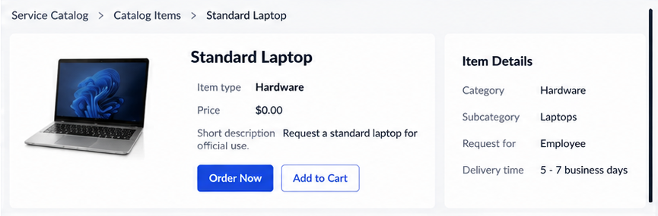
Figure 7.1: Standard Laptop Catalog Item – the catalog item available to requesters in the Service Catalog
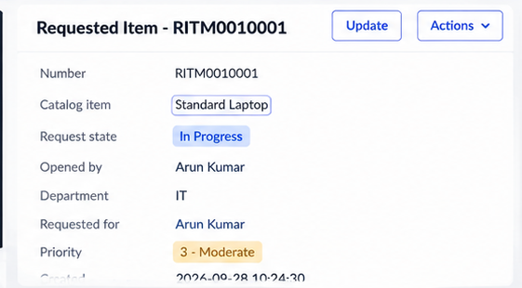
Figure 7.2: Laptop Procurement Request – the request form and submitted laptop request
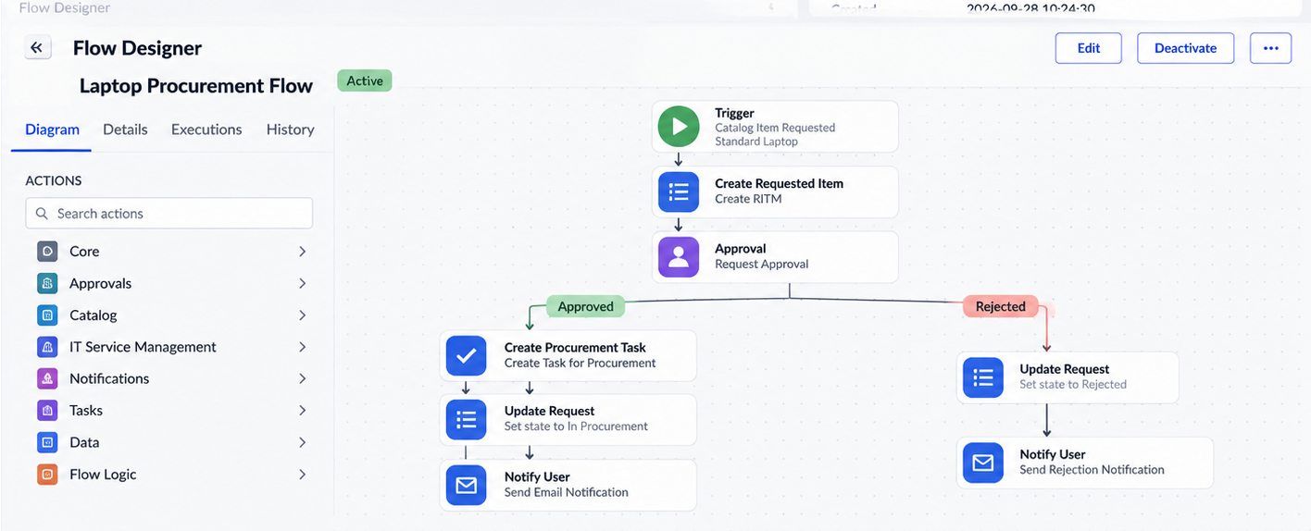
Figure 7.3: Flow Designer – Laptop Procurement Flow – the automated flow built in Flow Designer
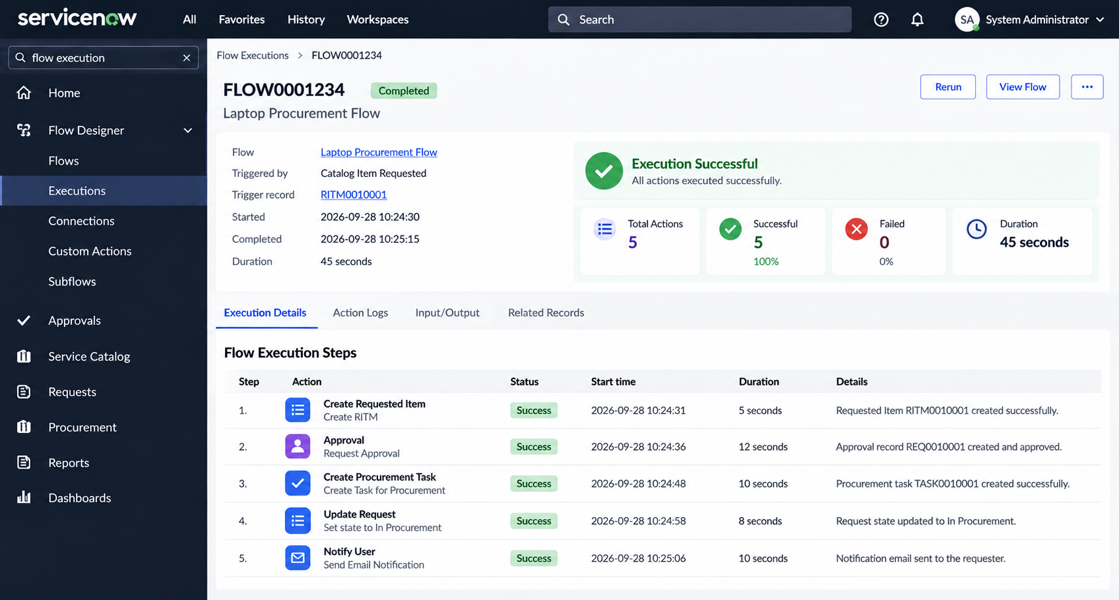
Figure 7.4: Approval – the approval generated by the flow
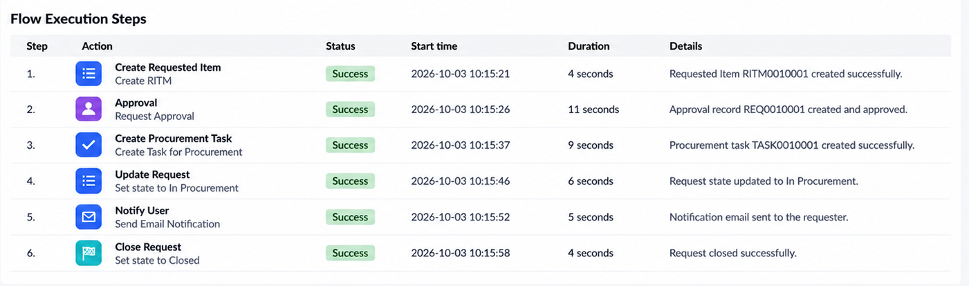
Figure 7.5: Procurement Task – the procurement task created after approval
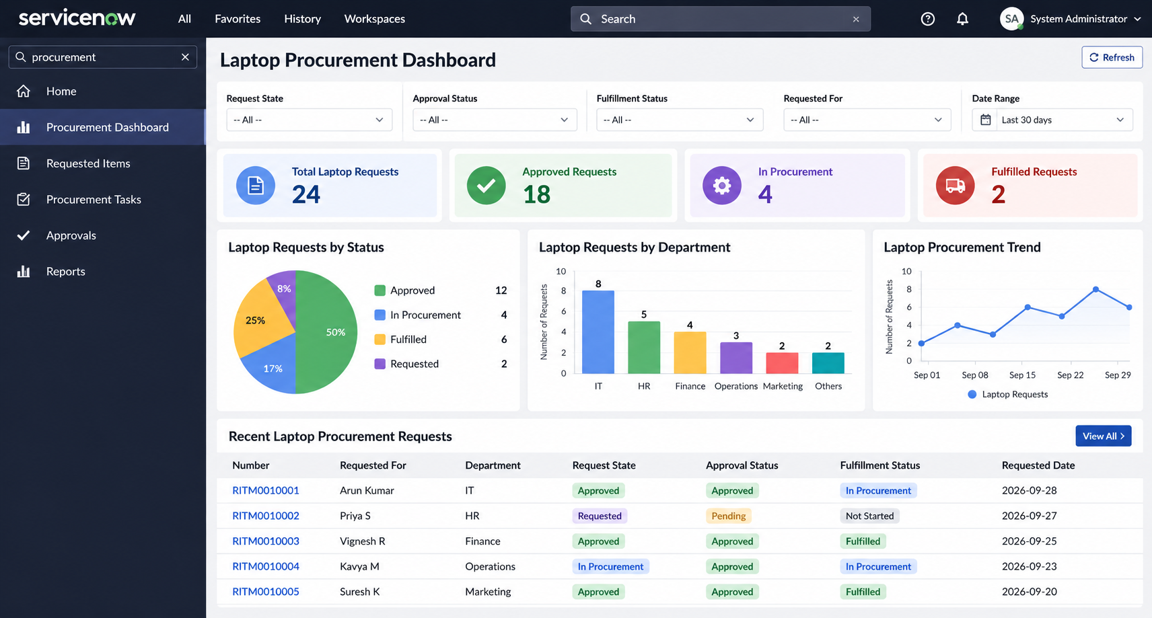
Figure 7.6: Laptop Procurement Dashboard – the dashboard for monitoring procurement requests
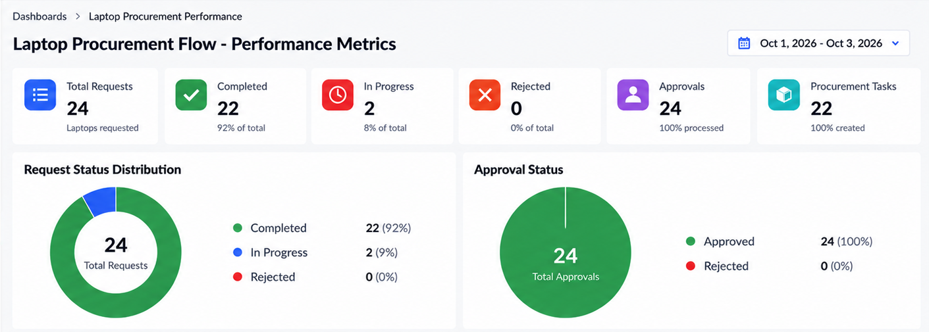
Figure 7.7: Laptop Procurement Story / Report – the report summarizing laptop procurement
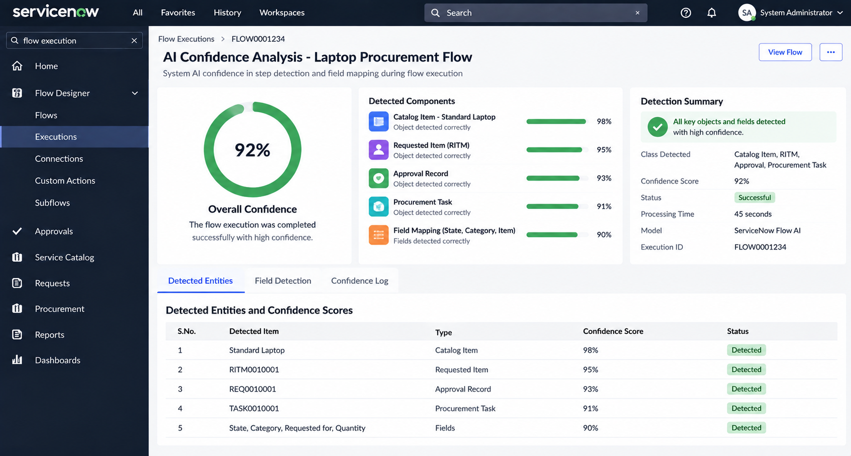
Figure 7.8: Model Summary – summary view of the implemented solution
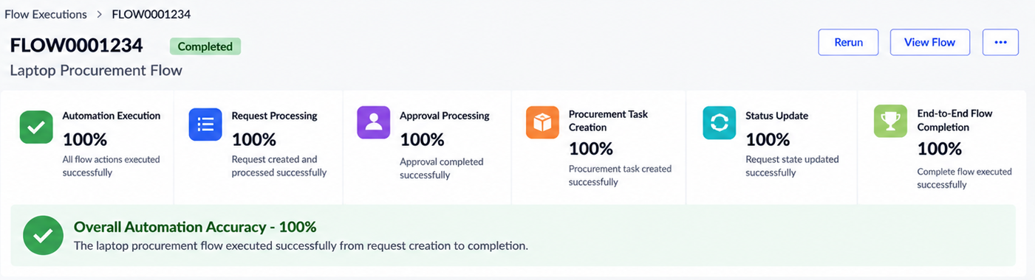
Figure 7.9: Accuracy – automation accuracy result
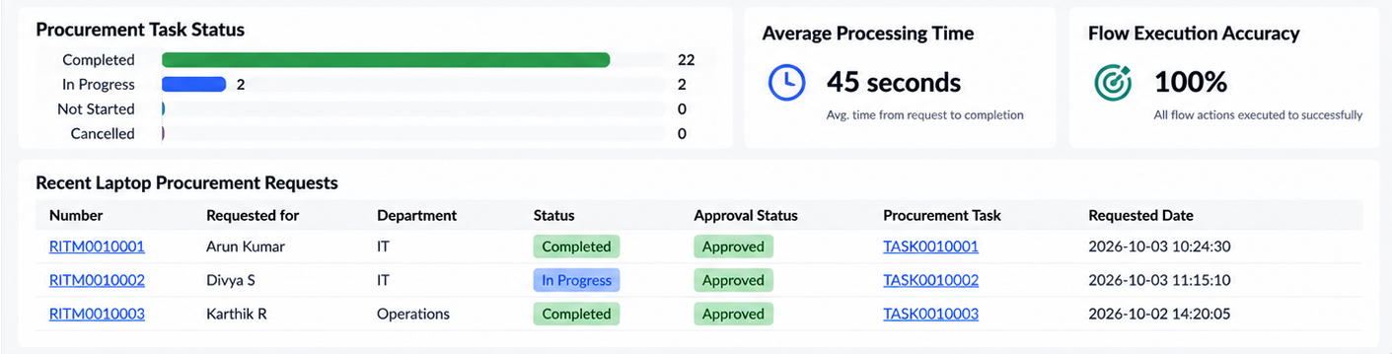
Figure 7.10: Performance Metrics – performance test results

8. ADVANTAGES & DISADVANTAGES
Advantages
- Reduces manual processing
- Automates repetitive procurement activities
- Improves approval workflow
- Automatically creates procurement tasks
- Provides consistent status updates
- Improves tracking and visibility
- Reduces processing errors
- Provides a scalable workflow
- Improves user experience
Disadvantages
- Requires ServiceNow configuration and maintenance
- Depends on correct workflow configuration
- Changes to procurement policies may require flow updates
- Requires appropriate ServiceNow permissions
- Integration with external procurement systems may require additional configuration

9. CONCLUSION
This project demonstrates that ServiceNow Flow Designer can automate the standard laptop procurement process. Through the Service Catalog, a requester submits a Standard Laptop request, and the flow automates the request, generates and processes the approval, creates the procurement task, and manages the request status through to fulfillment.
The end-to-end workflow gives the process a consistent structure, reduces manual effort, and gives requesters and the procurement team better visibility. The results reported in this document are from testing the workflow in the ServiceNow instance used for the project.

10. FUTURE SCOPE
- Automated inventory availability checking
- Automatic vendor selection
- Asset Management integration
- Automated email notifications
- Procurement cost tracking
- Approval escalation
- SLA monitoring
- Advanced procurement dashboards
- Hardware inventory integration
- Automatic laptop assignment
- External vendor integration
- Predictive procurement analytics

11. APPENDIX
Source Code (if any)
Not Applicable - The project is primarily implemented using ServiceNow configuration and Flow Designer rather than standalone source code.
Dataset Link
Not Applicable - This project does not require an external dataset.
GitHub & Project Demo Link
Not Applicable - The project is implemented within a ServiceNow instance.

